Asian Parliamentary Assembly

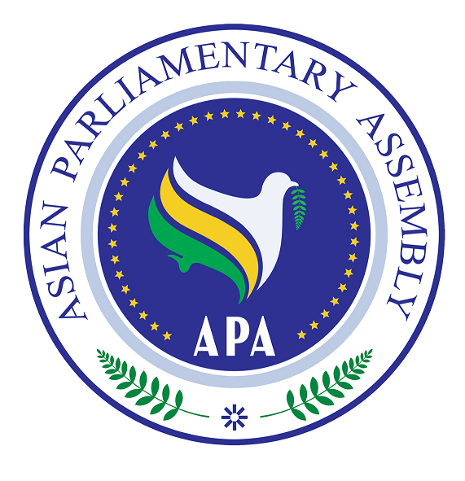

APA/Declaration/2009
10 December 2009

Bandung Declaration
On The Roles of Asian Parliaments in Strengthening Democracy towards Prosperity, Peace and Justice in Asia

Bandung, 10 December 2009

We, the Members of the Asian Parliamentary Assembly (APA), representing peoples in 41 countries which constitute more than 60% of the world population, gathered in Bandung on 7 - 10 December 2009 for the APA Fourth Plenary Session:

- Express the vital need to strengthen democracy in Asia to achieve prosperity, peace and justice in the region;

- Reiterate that strengthening democracy, promoting human rights and supporting the just and peaceful settlement of conflicts, in compliance with the norms and principles enshrined in both the APA Charter, the United Nations Charter, and international law, are essential in maintaining peace and security in Asia;

- Affirm our commitment to strengthen our parliamentary roles in promoting justice and opposing extremism for contributing to the peaceful settlement of conflicts, and the right to self-determination and preventing as well as combating terrorism in all its forms. We also reiterate our determination to prevent and reject stereotyping of religious, cultural or ethnic groups as well as nationality in association with terrorism, while, inter alia, encourage moderation, promote genuine interfaith and inter-cultural dialogue and building the public trust;

- Regret the minaret ban as an expression of intolerance, which has not only agitated the Muslims but also is considered contrary to cultures, religions and beliefs all over the world;

- Aware that, in view of the effects of climate change, little time is left for effective action to reduce significantly the emission of greenhouse gases, we emphasize the importance of concluding the agreement in Copenhagen in the light of the UNFCCC; Kyoto Protocol; Bali Roadmap; as well as the post-Kyoto climate change regime;

- Concerned with the seriousness of problems and threats posed by corruption, both at internal and international levels, undermining institutions and values of democracy, ethical values and justice and jeopardizing sustainable development as well as rule of law and reaffirm our parliamentary commitment and control to prevent and combat corrupt practices as stipulated in 2008 APA Resolution on Combating Corruption in Asia and the Statement of APA President on the International Day of Anti-Corruption, 9 December 2009;

- Call upon the United Nations and democracy-promoting states to facilitate the ending of foreign occupation and restoration of peace and take the necessary steps to uphold the right to self-determination of the Palestinian people and the establishment of the state of Palestine with Al-Quds as its capital, ending the siege of the Gaza Strip, liberating Golan in Syria and Shebaa farms in Lebanon as prerequisites to achieve just and fair peace in the area;

- Encourage our respective Asian governments to implement the sustainable development policies in order to ensure sustainable regionalism effectively and improve the quality of environment and to promote economic growth, democracy, peace, justice, prosperity and stability in Asia;

- Support the right of all nations to live in peace and prosperity and benefit from high technology including the right to develop nuclear programs for peaceful purposes in accordance with NPT especially for generating energy;

- Emphasize the importance of supporting the people of Afghanistan to live in peace free from foreign presence, and call on the United Nations to render assistance to the Islamic Republic of Afghanistan in combating illicit drug trafficking.

- Recognize that apart from terrorism, one of the most serious threats to peace, stability and security in the region and in the world is posed by transnational crime, human trafficking, kidnapping, and illicit drug and arms trafficking, which are frequently tied with common flows of funds.

- Recognize the rights of all people to self-determination and self- dependence to liberate their territories through legitimate means including resistance;

- Encourage Members of APA to maintain their commitments to the promotion and protection of the fundamental human rights of the people of Asia and call upon military authority in Myanmar to embark on the implementation of the road map to democracy in Myanmar;

- Call upon Members of APA to support and enhance the promotion of active participation of women in politics and decision-making process in Asia through legislation, policies and regulations;

- Request Members of APA to enhance their parliamentary roles in developing their concerted efforts to strengthen democracy towards prosperity, peace and justice in Asia.

Done in Bandung on the Tenth Day of December, In the Year Two Thousand and Nine.

